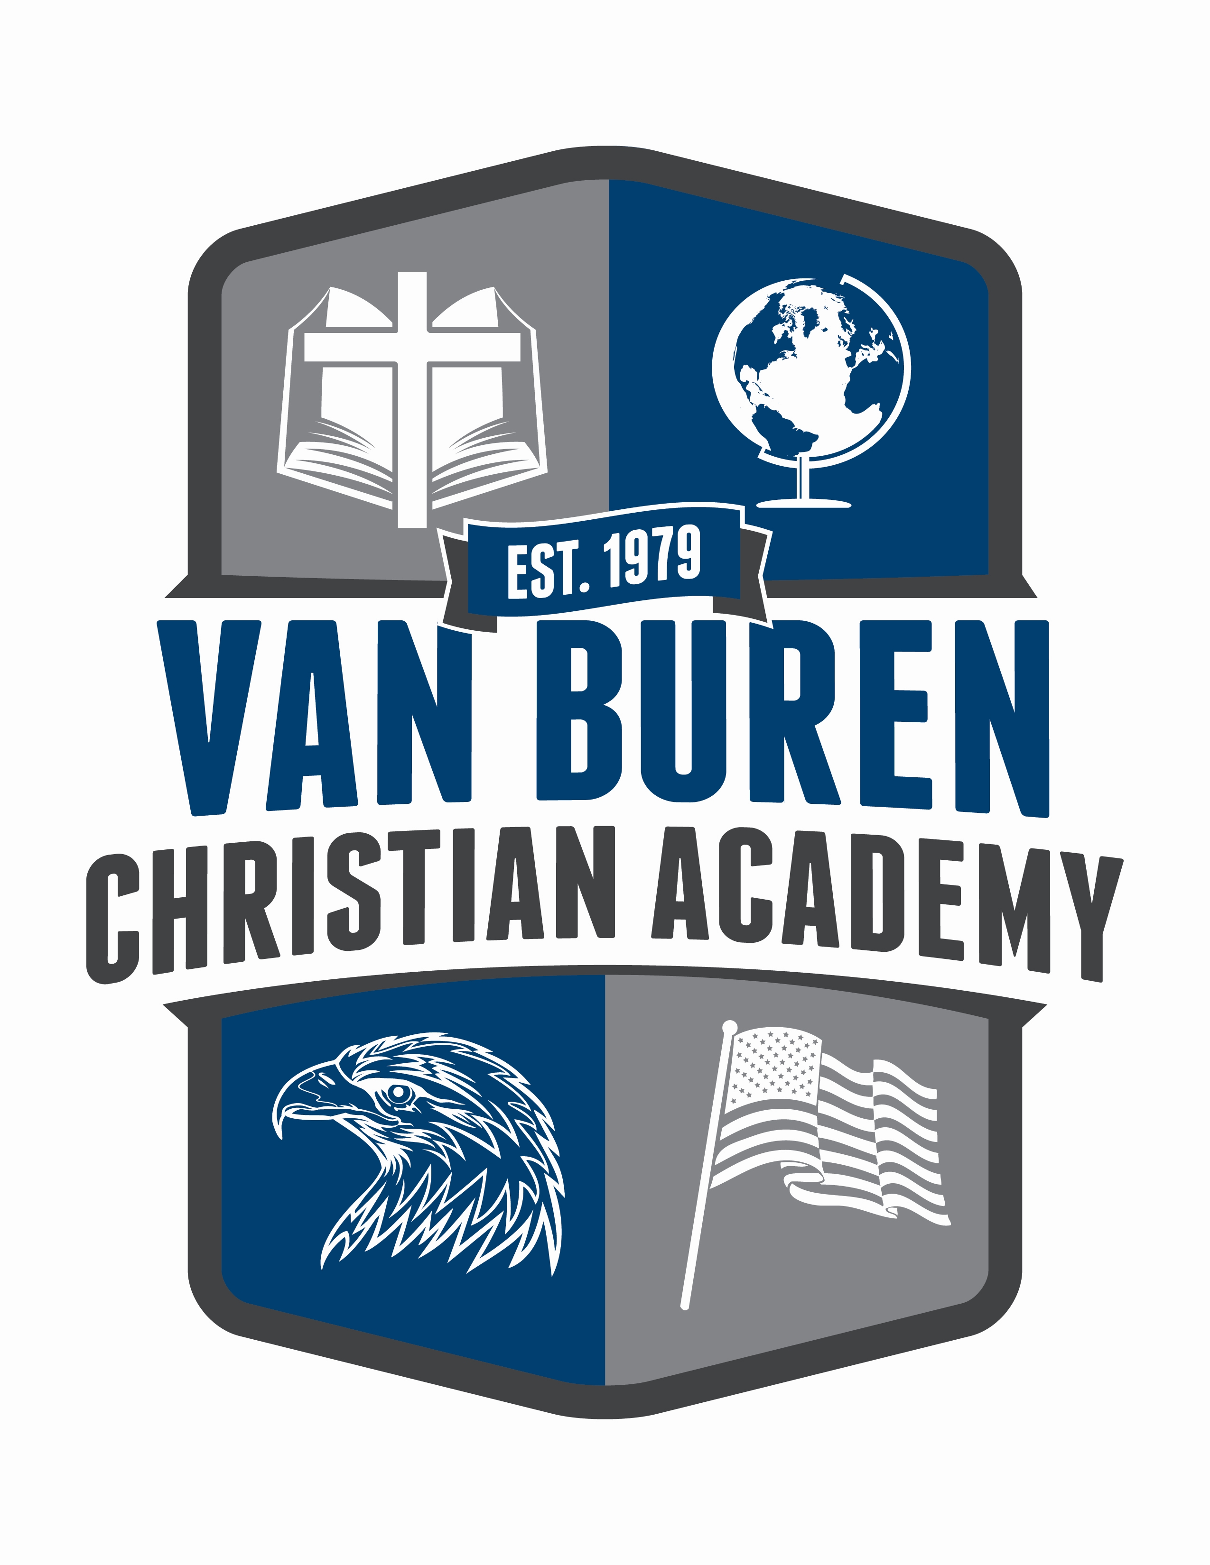
Tim Adair
Pastor/Administrator
Vista Free Will Baptist Church
(479) 474-0761

Mary Hays
Principal
Director of
Christian Education
(479) 883-7352

Liability Release Form

Van Buren Christian Academy, owned and operated by the Vista Free Will Baptist Church, will not be responsible to provide accident or liability insurance for any students. This is the personal responsibility of the student’s parents or legal guardian.

We, the parents or legal guardian of (child’s name) ___________________________ do understand that throughout the course of the school year it will be necessary for our children to travel with the school in order to participate in school-related activities. We, therefore, give our consent for our child to participate in scheduled activities. We will not hold any loss or claim of liability for accident, injury, incident or death against Van Buren Christian Academy or any member of its staff or the Vista Free Will Baptist Church or its official members.

We also understand that our student will be photographed on occasion and/or video taped in normal school activities and give our consent for our child’s (children’s) likeness to e used in promotions, publications, advertising, (including the official school website, without a name attached) and school year book along with their name in print.

_______ We give consent for our family name, address, e-mail address, and phone numbers to be printed in a school directory.

_______ We decline for our family name, address, e-mail address, and phone numbers to be printed in a school directory.

________________________________________________________________________
(Father’s signature) (Date)
AND

________________________________________________________________________________________________
(Mother’s signature) (Date)
OR

________________________________________________________________________________________________
(Legal guardian) (Date)

